Unit 4: Week 9 (Lesson 36)
Lesson Parts | Day 1 | Day 2 | Day 3 | Day 4 | Day 5
Overview/ Objectives | Use adverbs of frequency | - Develop short paragraphs through guided writing.  - Compose short paragraphs about familiar topics | Write the final draft of the write-up. | Share one’s write-up. | Compile the write-ups
Materials | - Pictures of pancit, banana cues, candies, chocolate bars, and biscuits  - Copy of ‘What Grade Three Pupils Like to Eat’ LM Activity 338  - LM Activity 339 | - Pictures of kids doing different activities  - LM Activity 340 | - Checklist on LM Activity 340  - LM Activities 341-342 | - LM Activity 343 | - Pair of scissors, coupon bond, linen paper, flower cutouts, coloring materials, folder and paste  - LM Activity 345
Procedures | (10 min)  Presentation/Introduction  - Post pictures of pancit, banana cues, candie, chocolate bars and biscuits on the board.  - Allow pupils to name the pictures.  - Let them line up to their food preferences.  (15 mi)  Modeling/Teaching:  - Read with the pupils ‘What Grade Three Pupils Like To Eat’ and present the table and the graph on a Manila paper. Refer to LM- Activity 338  - Review adverbs  - Discuss adverbs of frequency  (15 min)  Guided Practice:  - LM Activity 339  (10 min)  Independent Practice:  - Ask each pupil to write a sentence using adverbs of | (10 min)  Presentation/Introduction  - Post the 5 pictures on the 5 corners of the room and ask the pupils to tell what they see on each picture.  - Let each one choose a picture and stay in the corner.  - Review the rules on punctuation, spellings, sentence, ang paragraph writing using the checklist on LM Activity 340  (10 min)  Modelling/Teaching:  - Present issues on global warming and the need to help in cleaning and greening our environment.  (10 min)  Guided Practice:  - Ask the pupils to brainstorm in their group on how to keep our environment clean and green.  (20 min)  Independent Activity:  - Ask the pupils to go | - Review the activity done the previous day.  - Let the pupils review each other’s write-up in groups and in pairs using the checklist.  - Let them write the second draft and the final draft. –LM Activity 342. | - Let the students review their write-up.  - Let them revise their work based on the checklist.  - Ask pupils to write the final draft.  - Ask one or two members from each group to share their work.  - Post the pupil’s work on one corner of the room and let them do a Gallery Walk.  - Let them bring the materials started in LM Activity 344. | - Ask the pupils to bring out their materials.  - Let them compile their write-ups.  - Let them refer to LM Activity 345 for the guidelines.

Unit 4: Week 9 (Lesson36)
What Grade Three Pupils Like to Eat?

- Presentation/Introduction
(Materials: Picture of pancit, banana cues, candies, chocolate bars and biscuits)
Post the following pictures on the board.
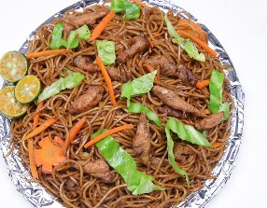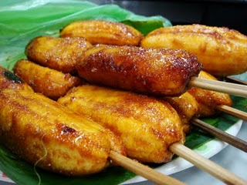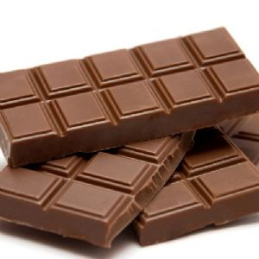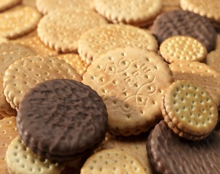
Ask: What are these? (Post the chart below. Allow pupils to name the pictures.) If these were sold in our school canteen, which would you rather have for recess? I want you to stand and line up beside the food you would like to eat for recess. (Allow pupils to line up beside their preferences.) How many of you lined up beside pancit? Banana cue? Candies? Chocolate bars? Biscuits? (Count and list the preferences of pupils.)

Food Preferences
What would you like to eat? | Pancit | Banana Cue | Candies | Chocolate Bars | Biscuits
How many of you preferred the following food items?

- Modeling and Teaching
Read with the pupils ‘What Grade Three Pupils Like to Eat’ and present the table and the graph on a Manila paper.
Read the following story. Take note of the highlighted words.

What Grade Three Pupils Like to Eat
By: Ma. Criselda G. Ocang

I have always wondered what kinds of food kids, like me, buy from the school canteen during recess. So, as a project for our Math class, I did a mini-survey. For five days, I recorded what Grade Three pupils bought at the canteen. This table shows the results.

Foods Bought by Grade Three Pupils for One Week
Food | Monday | Tuesday | Wednesday | Thursday | Friday | Total
Pansit | 7 | 10 | 2 | 12 | 4 | 35
Banana Cue | 10 | 8 | 8 | 10 | 12 | 48
Biscuits/ Crackers | 13 | 10 | 10 | 10 | 16 | 59
Chocolate Bars | 6 | 7 | 12 | 8 | 4 | 37
Candies | 4 | 5 | 8 | 0 | 4 | 21

I also made a bar graph about the results shown in the table. It looks like this.

Wow! Grade Three pupils often eat biscuits or crackers for their snacks. Other snacks they usually eat are banana cues and chocolate bars. They seldom eat pansit. And they rarely buy candies. That’s a surprise! I’ve always thought kids love candies.
One thing is for sure, though. The kids in my school are never hungry.

Adverb

Learning adverbs is fun. This time you are going to write sentences using adverbs by answering the following questions.
Do this in your notebook.
REMEMBER:
Adverb
An adverb describes a verb, an adjective or another adverb.

- How do you walk? I walk ________________________________.
- If you are very tired, how slow would you be in eating your
breakfast? I would _________________________ eat my breakfast.
3. If you would be receiving a mobile phone on Christmas, how
happy you might be? I might be ____________________________.
Review on adverb and introduce/discuss adverbs of frequency.
Ask: Remember the discussion we had last week on adverbs? Let’s review them.

Use the following diagram to recall it.
What are adverbs?
Adjectives
Verbs
ADVERB
Adverbs

Adverb describe a verb, an adjective or another adverb.
Ask pupils to write sentences from the text that contain the highlighted adverbs.
Say: Let us write the sentences from the text that contain highlighted words which we call adverbs.
Discuss each of the sentences. Ask questions after each sentence.
I have always wondered what kinds of foods kids, like me, buy from the school canteen during recess.
How often does he wonder about what kinds of foods kid buy from the school canteen?

Grade Three pupils often eat biscuits or crackers for their snacks.
How often do Grade Three pupils eat biscuits or crackers for their snacks?

Other snacks they usually eat are banana cue and chocolate bars.
How often do they eat banana cue and chocolate bars?

They seldom eat pancit.
How often do they eat pancie?
They rarely buy candies.
How often do they buy candies?

I’ve always thought kids love candies.
How often does he think kids love candies?

The kids in my school are never hungry.
How often do the kids in his school get hungry?

The highlighted words and the answers you gave for the questions are ADVERBS OF FREQUENCY. An adverb of frequency tells how often you have done something.
- Guided Practice

Read the following story and take note of the highlighted words in the text.
A Plan
By: Jeanette V. Sison
“Yehey, it’s vacation time,” shouted Miguel.
“School days are over,” added Samantha.
“Let us start planning our Summer Vacation!” Father shortly added.
Suddenly, Mang Cardo the postman called loudly outside for Mother. “Aling Martha, you have a letter from your brother,” he yelled.
Mother eagerly went outside to get the letter from him.
“I seldom receive a letter from Anton,” she wondered.
“Anton is inviting us to have a vacation in Baguio City. We never had a chance to visit him and his family,” she smiled.
“That is good! It will be a treat for all of us,” Father warmly added. Samantha and Miguel giggled happily about the good news.

REMEMBER
Adverbs of manner tell us the way something is done. It answers the question how.
REMEMBER
Adverbs of manner tell us the way something is done. It answers the question how.

(Note: Bes sure to prepare the posters below.)

seldom
I brush my teeth once a day.

never
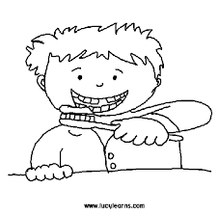
I do not brush my teeth.

often

always
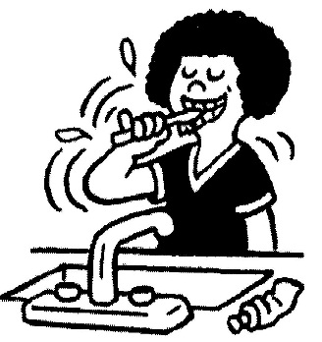
I brush my teeth 2 times a day.
I brush my teeth 3-5 times a day.
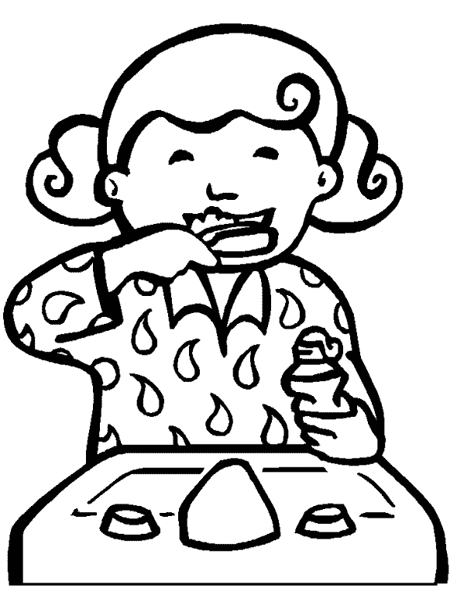

The pupils will answer the questions and go to the poster that reflects their choices: always, usually, often, seldom, rarely, or never. All responses are accepted.
How often do you brush your teeth? (If they choose NEVER, they would say I NEVER BRUSH MY TEETH.)
(You may ask many questions as you want.)
Adverbs of Frequency
REMEMBER:
Adverbs of Frequency are used to say ‘how often’ you do things.

How often do you brush your teeth?
How often do you go to your dentist?
How often do you comb your hair?
How often do you wash your hair?
How often do you buy a comb?
How often do you drink water?
How often do you drink milk?
How often do you drink wine?

- Independent Practice
This time go to your group then each of you will write a sentence using any of the ADVERBS OF FREQUENCY on the Manila paper. Be ready to read and share your work to class.

Lesson 36 Day 2: Pre-Writing and Writing the First Draft

- Presentation/Introduction

Materials: (1) Picture of kids sweeping, (2) Re-using bags and tin cans, (3) gardening/planting, (4) throwing garbage in the right bin, (5) talking to fellow on how to keep the environment clean and green. (lobbying)
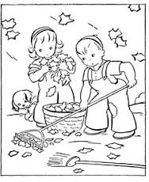
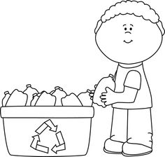

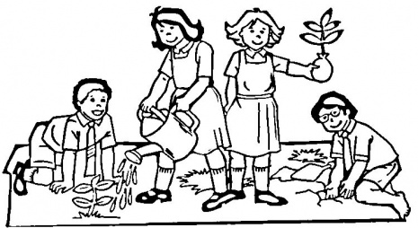

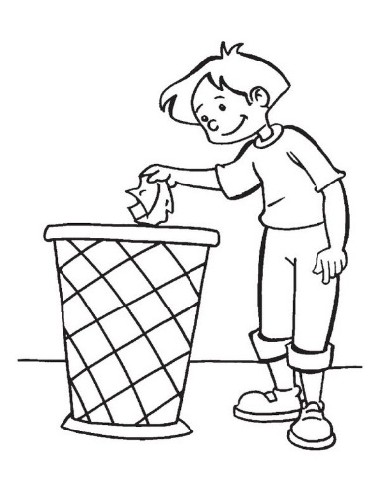
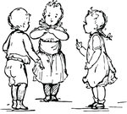

Post the pictures on an arm chair or desk in 5 different activity corners in your room. Pupils will choose what they want to do to keep our environment clean and green.
We have 5 activity corners in our room. What is the picture that you see on the first one? The second one? The third one? The fourth one? The fifth one?
Allow them to answer each of your questions. Then ask: From these five, what would you want to do to keep our environment clean and green?
Give pupils a minute to decide and go to the corner of their choice. The pupils will stay in their corners but when one group exceeds the number of pupils in a group split the corner/group. Tell them to stay there.

- Modeling/Teaching
Review the rules on punctuation, capitalization, spelling, sentence and paragraph writing using the checklist.
Pre-Writing and Writing the First Draft
It is writing time. We are going to review our written work. Let us not forget this Writing Checklist before we start writing. Let us read the first one.

 | Yes | No
CAPITALIZATION
Do the important words in the title begin with a capital letter?
Does each sentence begin with a capital letter?
Did you write the word I with a capital letter?
Do the names of persons and places begin with a capital letter?
Do the names of weeks, months and holidays begin with a capital letter?
PUNCTUATION
Do the questions end with a question mark?
Do the statements (declarative and imperative sentences) end with a period?
Do the exclamatory sentences end with an exclamation point?
Do the series of things or events that were enumerated use a comma?
SPELLING
Are the words used in the write-up spelled correctly?
SENTENCES
Do the paragraphs start with an indention?
Do the sentences have a complete thought?
Is the write-up written legibly?

Present issues on global warming and the need to help in cleaning and making an environment green.

- Guided/Independent Practice

In your group now, you are given 7 minutes to talk about how you can keep our environment clean and green. Do not forget to write the important details of what you are going to talk about.
You are given time to talk about how you can keep our environment clean and green. Do not forget to write the important details of what you are going to talk about. After that, you will return to your seats and start writing on the topic ‘How I Can Make My Place a Better Place to Live In’.

After 7 minutes the pupils will return to their seats and start with the writing activity on How Can I make Our Planet Earth a Better Place to Live In?

Lesson 36 Day 3: Peer-Review and Revising (First Draft)
Materials: Teacher Chart (Checklist on Reviewing and Revising Write-up/Writing Checklist)
What did we write about yesterday? Do you think you have a good write-up already?
Tell pupils to go to their group and find a pair. Post the checklist on the board.
Go to your group and review each other’s work. Be guided by the posted checklist.
Pupils will be given 10 minutes to review outputs. Remind them again on the guidelines. Refer to LM-Activity 341 on page ___.
Pre-Writing and Writing the First Draft
It is writing time. We are going to review our written work. Let us not forget this Writing Checklist before we start writing. Let us read the first one.
 | Yes | No
CAPITALIZATION
Do the important words in the title begin with a capital letter?
Does each sentence begin with a capital letter?
Did you write the word I with a capital letter?
Do the names of persons and places begin with a capital letter?
Do the names of weeks, months and holidays begin with a capital letter?
PUNCTUATION
Do the questions end with a question mark?
Do the statements (declarative and imperative sentences) end with a period?
Do the exclamatory sentences end with an exclamation point?
Do the series of things or events that were enumerated use a comma?
SPELLING
Are the words used in the write-up spelled correctly?
SENTENCES
Do the paragraphs start with an indention?
Do the sentences have a complete thought?
Is the write-up written legibly?

This time, get your reviewed copies and write your second draft.
After revising the first draft, pupils will be given the chance to review the second draft and be guided by the checklist once again.
This time, get your reviewed copies.
Pre-Writing and Writing the First Draft
It is writing time. We are going to review our written work. Let us not forget this Writing Checklist before we start writing. Let us read the first one.
 | Yes | No
CAPITALIZATION
Do the important words in the title begin with a capital letter?
Does each sentence begin with a capital letter?
Did you write the word I with a capital letter?
Do the names of persons and places begin with a capital letter?
Do the names of weeks, months and holidays begin with a capital letter?
PUNCTUATION
Do the questions end with a question mark?
Do the statements (declarative and imperative sentences) end with a period?
Do the exclamatory sentences end with an exclamation point?
Do the series of things or events that were enumerated use a comma?
SPELLING
Are the words used in the write-up spelled correctly?
SENTENCES
Do the paragraphs start with an indention?
Do the sentences have a complete thought?
Is the write-up written legibly?

Lesson 36 Day 4: Generating Final Copy

Materials: Chair- labeled as AUTHOR’S CHAIR
Post the checklist and ask the pupils to hold their write-ups. This time the pupils will review their own work through the help of the teacher following the checklist. Ask the questions from the checklist one by one and give them ample time to lock at their work.
This time, get your reviewed copies and write your final draft.
Now, we will listen to one or two members from each group to read his/her work to us.
Determine the reader/sharer by drawing lots. Tell pupils to share work in class on the Author’s Chair and reading their work. Tell each group to prepare a yell to their group mate. Collect copies of the final draft and post them on one corner for a Gallery Walk. Make sure each of the work of the pupils are displayed for everyone to see.
As an assignment, ask pupils to bring scissors, coupon bond, linen paper, flower cutouts, if available, coloring materials, folder, and paste for the next day activity.

Lesson 36 Day 5: Compilation of Write-ups
Materials: pair of scissors, coupon bond, linen paper, flower cutouts if available coloring materials, folder, and paste for the compilation.
Post the guidelines for the compilation of the write-ups as a project of the group 3.
Compilation of Write-ups
You are going to compile the write-ups as your project. Please remember the following guidelines before starting with your work.
Parts of the Compilation | Contents of the Part | Remarks
Cover Page | - A poster or a drawing reflecting the topic developed in the write-up and the Group Name
Table of Contents | - Title of the Write-up with the name of the author/ writer and page number
Write-Ups | - All the work of the members of the group with illustrations (at least 3 including the cover page)

