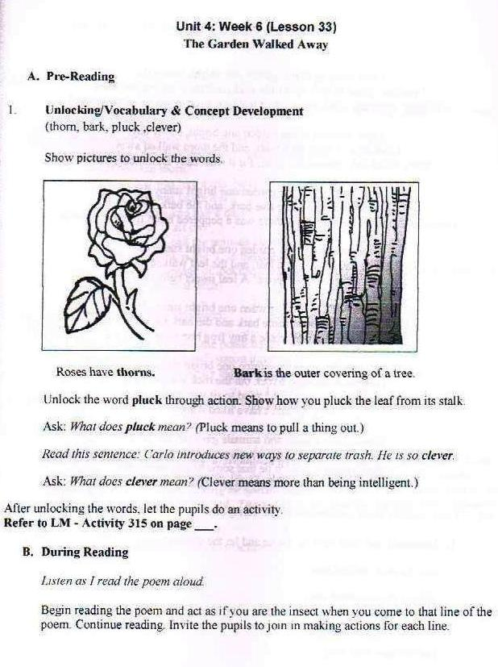
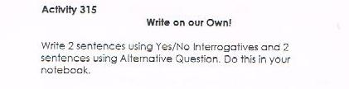
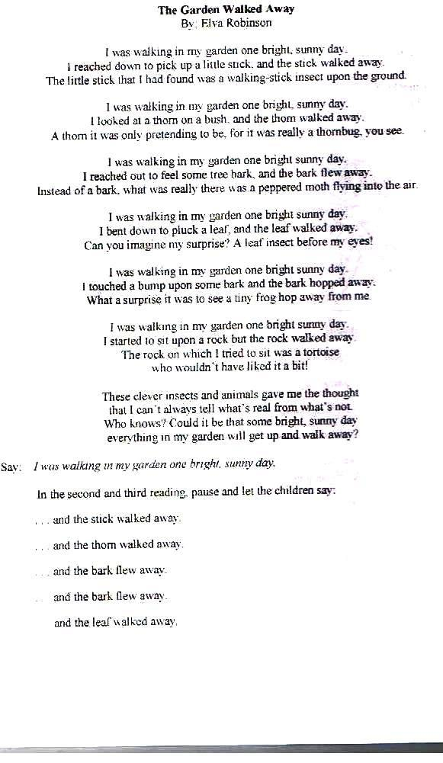

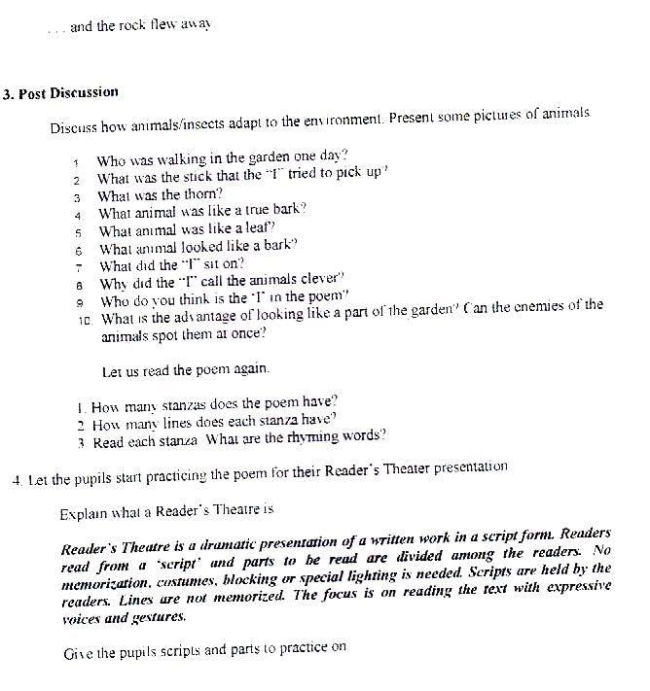

Objective: Engage pupils in poem reading
Suggested Activities
- Using Poetry to Teach Reading
Retrived from http://www.readingrockets.org/article/using-poetry-teach-reading

Begin the school year by preparing a pocket folder for each child labeled "Poetry" and by preparing copies of two poems. I used a school theme. On the first day of school, begin this activity by reading a poem to the students. Then pass out a copy of the poem to each child and reread it to the students as they follow along. Then read the poem together chorally. Poetry lends itself to choral reading because of its rhythm. Follow the same procedure with the second poem.
School
School is something,
we must all embrace.
Knowledge we need,
to seek out and chase.
Subjects and teaching styles,
are plentiful and vary.
Just like the backpacks,
we all need to carry.
Sports, clubs, and activities,
at every single turn.
So much to do,
study and learn.
To get the most from school,
we should consistently attend.
Around each corner,
there's always a friend.
Our favorite teachers,
are friendly and kind.
Their passion and job,
to expand every mind.
School is something,
we must all embrace.
Just remember to learn,
at your own pace.
by anitapoems.com
Understand
School is often,
a serious affair.
Your teacher expects you,
to sit straight in your chair.
During classes you don't fancy,
you may be sporting a frown.
Just be careful,
your grades may go down.
Education certainly begins,
with a positive attitude.
For this opportunity,
let's show some gratitude.
The trick is to enjoy,
subjects you find curious.
The ones you don't like,
are not injurious.
Remember to physically,
and mentally train.
It all begins,
with your beautiful brain.
Your classmates may need,
a helping hand.
You're a good student,
you understand.
by anitapoems.com

Classroom Poetry Charades
Retrieved from http://www.poetry4kids.com/blog/activities/classroom-poetry-charades/

Kids love to get up and get moving, which is great because movement can help reinforce learning. Most children also love games. Put movement and games together, and you have a high energy activity that can be done quietly in any classroom: Charades!
The following game of charades uses the twenty-seven activities found in the poem “I Don’t Know What to Do Today.” It’s simple to prepare, exciting, and teaches children that poetry is fun while helping them reinforce important skills like memorization, cooperation, and word association.
- Prepare the game cards: On note cards or slips of paper, write each “part” of the following poem. Use one color for any words that are not part of the action, such as “Maybe I’ll go” in the phrase “Maybe I’ll go ride my bike.” Use another color for the action phrases. This way the children can identify their action, but still be able to put together the entire poem at the end of the activity.Write the first line of the poem, “I don’t know what to do today,” and the last verse, “I’m so confused…” on their own cards to be used in the last part of the activity. Do not distribute these to the students.
- Write the poem on the black board, or distribute individual copies of the poem to students.
- Read the poem out loud together.
- Distribute the “game cards,” one to each student. Ask them to look at their card, then turn it upside down on their desk. It’s a secret!
- Explain the rules of charades:
  - Tell them to use their body to act out the activity written on their card.
  - NO talking!
  - You may want to put a time limit on each turn.

- Host an Open Mic Poetry Party for Kids
Retrived from http://www.poetry4kids.com/blog/lessons/how-to-host-an-open-mic-poetry-party/

How to Host an Open Mic Poetry Party for Kids
Having an open mic poetry party is a great way for kids to showcase their talent while encouraging them to keep writing. Whether the children are budding poets, stand-up comedians, or just need some practice with public speaking, in a few simple steps you can provide everyone with a fun way to enjoy live poetry!

Step One: Decide on a Venue
Think about the type of party you’d like to host. Will it be a small gathering of friends, perhaps for a birthday or special occasion? Is it for your class, scout troop, or youth group? The size of the group, as well as the purpose of the party, will help you determine your venue.
There are many different places that would be great for an open mic night/party. Libraries have meeting rooms or sometimes stages that can be reserved for free or very low cost. Book stores and coffee shops often host open mic nights and poetry readings. Rooms in schools and churches can also provide a nice space. Even just your own living room can work well for small groups.
Once you decide on a space, you’ll have to call ahead and book it, as sometimes locations require reservations weeks or even months in advance.

Step Two: Create an Invitation
If your open mic is a birthday party, you’ll want to get your invitations out several weeks ahead. However, if it’s for your class or other organization during regularly scheduled hours, you just need to give your students or members enough time to gather their words. A week should be fine.
Your invitation should include the name of the event, time, date, location (including map or directions), and a number to RSVP. Also tell guests to bring a poem to read. It could either be one of their own, or one of their favorites!

A simple invitation might look like this.

Poetry Party
The party is on.
Cake, games, poems read out loud.
I hope you can come.
What: | Celebrate Jack’s birthday with an open mic poetry party!
When: | Saturday, March 10th, 2:00pm – 5:00pm
Where: | Smalltown Public Library  Meeting Room B200  West Main, Smalltown, MI (map included)
RSVP: | To Mary at 123-456-7890
Please bring a poem of your own to read, or one by your favorite author!

If you know all of your guests’ mailing addresses, you can send an old-fashioned paper invitation. If not, an e-mail or online invitation (such as Evite) works just as well.

Step Three: Gather Supplies
Prepare for your open mic party by gathering all of your supplies well in advance, except the perishables. No-one likes stale cupcakes! You’ll need:
- A microphone: This can be hand held or on a stand, plugged into speakers, an amplifier, or stereo. Think about your space and what kind of acoustics you’ll have.
- Seating: Most venues will provide plenty of seating. But if you’re doing it at home, just make sure there are enough chairs for all the guests and space enough to line them up in rows.
- Sign-up sheet: A sheet of lined paper numbered down the side works fine, or you can create a document on the computer. You’ll want kids to sign up when they arrive so they know their reading order ahead of time.
- Activities: If you plan on having games in addition to the reading, make sure you have them ready. See below for suggestions.
- If you are serving food, you’ll need cups, plates, napkins, and utensils.

Step Four: Party Time!
On the day of the party, set up the mic and seating. Make sure all of the food is prepared and supplies are on hand. Test the microphone to make sure it’s working. Once you greet your guests, have them sign up for a slot to read.
You can organize your party time any way you like. If it’s a younger group, you might want to start out with some activities to get their creative juices flowing and help them get comfortable with each other. If it’s a meal time and you have food, you may want to let them eat first. That part is flexible. But it’s best to have everyone get seated at the start, take the mic yourself, explain the course of events, and tell them how “snapping is clapping” at a poetry reading. Kids love this!

- “ Luck of the draw Poetry Recital”
Retrived from http://www.poetry4kids.com/blog/activities/lucky-dip-poetry-recital-game/

Host a “Luck of the Draw” Poetry Recital
When it comes to poetry recitals, it’s not unusual to feel a bit nervous; why not lighten the mood by turning the event into a game?
Whether your group are studying a particular poem, poet or topic – or whether you’ve been writing your own poems – you can bring some excitement to the event by creating a ‘lucky-dip’. A ‘lucky-dip’ is a British game, where small prizes are concealed inside a large container, and players have to reach inside and grab one without being able to see what it is. In this recital game, the prizes are the poetry!

Getting Ready
First, decide what you will be reciting. The text will need to be printed onto slips of paper. If you have been looking at one particular poem, each slip could have one line or phrase; if you have been studying a poet, or a theme, the slips could have short extracts of relevant poems; if your group have written their own poems, each one could be printed on an individual slip… Make sure you have enough printed slips for everybody in the group to receive one!
Next, find 2 large hats, buckets, pillowcases or similar containers. You could even get the group to decorate 2 cardboard boxes to match the theme of the recital! Fold all the slips of paper and hide them inside one of the hats.
Now you need to print the names of everyone who will be participating onto additional slips of paper (you could make these a different color so you don’t get mixed up!) and these are folded up to go into the other hat.

How It Works…
You are now ready to begin the game. You can be informal and get the group to stand in a circle, or you could set up a ‘stage’ area if you want to be a bit more dramatic.
When everyone is ready, it’s time to pull the first name from the hat. That player can then come and take a ‘lucky dip’ from the other hat, and their task is to recite the poetry text to the rest of the group! Accomplished readers can deliver their recital immediately or, alternatively, you can wait until everyone has drawn their text from the hat before going back to the first person and asking them to read (this gives a little preparation time if necessary.)
After the first player has given their recital (or chosen their slip to read), they can then pick another name out of the first hat to decide who goes next, until everybody has had a turn.
Make sure you reward each player with a big round of applause, and three cheers to celebrate when everybody has had a turn and the ‘lucky dip’ recital game is finished!

Tips
- If the slips make up the lines or couplets from a single poem, you can number the slips. Then players can read them in the numbered order to recite the entire poem.
- I have some tips for delivering a great recital here. You could share some of these with the group beforehand.
- This activity should be about making recital fun, and taking out the fear factor – it’s ok if someone stumbles or makes a mistake!
- If your group enjoy this sort of activity, why not invite an audience next time?

- Smelling Game
Retrived from http://www.poetry4kids.com/blog/activities/poetry-smelling-game/

Your world is shaped by the information you take in through your senses. You know which ice cream you like best because of your taste buds. You know that you shouldn’t touch the stove top because of your sense of touch. The sirens warn you to get out of the way! And most importantly, your sense of smell keeps you away from the toxic stench emanating from the facilities after your brother spends an hour “resting!”
But what if you couldn’t trust those senses anymore? That’s exactly what happens in the following poem, where the character’s senses turn up all backward. Imagine describing the spray of a skunk as delightful, and the smell of a rose as hideous. People would think you were crazy! Do you think this poem is a bit crazy?
My Senses All Are Backward
My senses all are backward
and it really makes me wonder
if on the day that I was born
somebody made a blunder.
For, strange but true, my senses
all got totally reversed.
Now everything I like the best
is what you’d call the worst.
I only like the smell of things
that frighten other noses.
I love the odor of a skunk.
I hate the smell of roses.
I only like the taste of foods
that cause most folks to shiver.
I hate the taste of chocolate.
I’m crazy over liver.
I’m not too fond of music
but there’s simply no denying
I like the sound of honking horns
and little babies crying.
I hate the feel of silky, velvet
softness on my skin.
I much prefer the way it feels
when sitting on a pin.
I hate the look of anything
that’s really cute and snuggly.
The things I think are pretty
are what most consider ugly.
So let me tell you one more thing
before I have to go:
I think YOU are the most attractive
person that I know.
–Kenn Nesbitt
Wait, did the poet just make a really sly dig at me? Look what happens when your senses get flip-flopped. This guy can’t really trust his senses any more, can he? The real question is, can YOU trust YOURS? Try out this next project to see if you can trust your own sense of smell.

What you’ll need
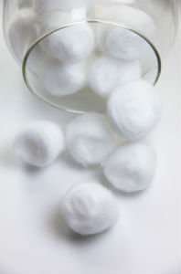
- 6 Plastic eggs, each a different color (like the type used for Easter Baskets)
- 12 Cotton Balls
- 2 sheets of paper and 2 pencils
- Various liquid scents
You can use anything liquid with a strong odor that won’t spoil. Here’s what I used: Vanilla extract, pickle juice, lilac scented air freshener spray, peppermint extract, Old Spice spray deodorant, garlic oil

Directions
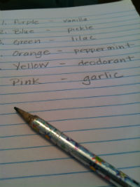
- On a sheet of paper, write down the color of each egg.
- Separate the cotton balls into pairs, two cotton balls per egg.
- Squirt a little bit of one scent on the first pair of cotton balls. You want them scented, but not soaked.
- Place the two scented cotton balls into one colored plastic egg and snap it shut.
- Write the scent on the sheet of paper next to the corresponding color.
- Repeat steps 3 – 5 until all of the eggs are used and the color-scent combinations are written down.
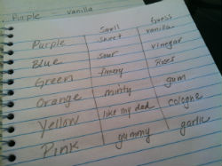
To Play the Game
- Hand a blank sheet of paper and a pencil to your friend.
- Ask them to write down the colors of the eggs on the paper.
- Hand them one egg and ask them to sniff it. Explain that they need to try to guess what smell is inside the egg.
- Ask them to write their guess next to the egg color on the paper.
- Next to their guess, have them write one adjective that describes the smell (i.e. sweet, spicy, funky, gross)
- Repeat until they have guessed all of the eggs.
- Tell them what was actually in the eggs!
- Repeat with another friend as many times as you like!
To Write a Poem
Once you have gathered the guessing-papers from your game, you can use the answers to write your very own “smelly poem!” Choose one of the colored egg contents as the focus of the poem. Write down all of the guesses and the adjectives in your poetry journal. Add some words of your own if you want to! Use your notes to write a silly poem about smells. Here’s the one I wrote from the words used to describe vanilla, and the guesses about what was in the egg.
Vanilla
Is it ice cream, is it cookies, maybe it’s a pastry?
It smells so sweet and yummy,
Creamy, delicious, tasty.
If you let me open it, I’ll eat it,
Yes, I will-a. You know that I always love
The flavor of vanilla!

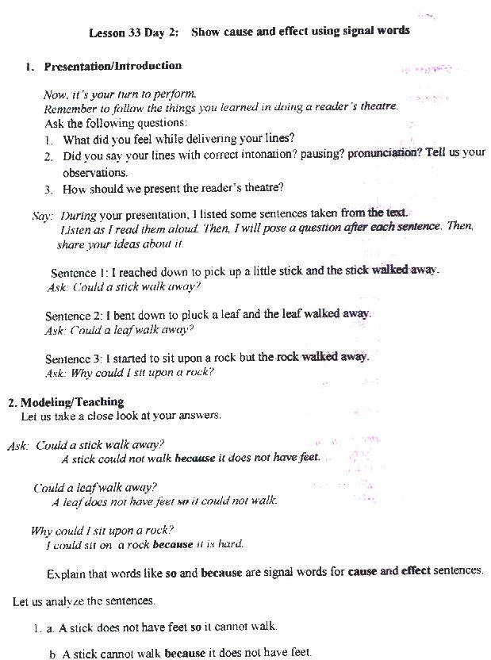

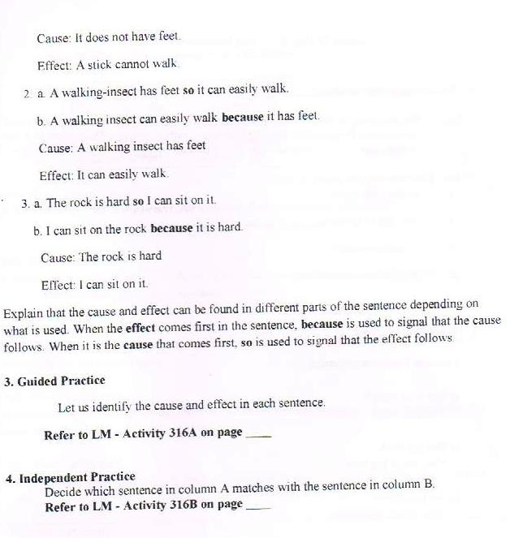

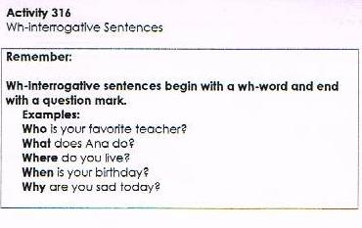

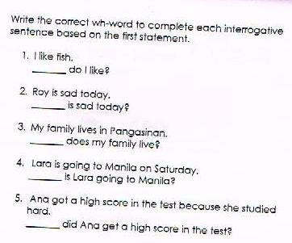
Objective: Show the cause and effect using signal words
Suggested Activities
Retrieved from http://www.proteacher.org/a/109709_Cause_and_Effect.html

Thinking Map to teach Cause and Effect
I love using 'If You Give A Mouse A Cookie' by Laura Joffe Numeroff to teach cause and effect. The whole story is based on a series of causes and effects. Mandy Gregory's website has a great week-long lesson plan based off of this book. I think she teaches fourth grade as well.
In my fifth grade classroom, I use a Thinking Map to teach cause and effect. I have students brainstorm events that might happen on a school day, like dropping a tray in the cafeteria, getting a good grade on a test, being late for school, etc...Then on the left of the event, they list three things that might cause this event. For example, if the event was dropping their tray in the cafeteria, a cause might be that the floor was wet. Then on the right of the event, the students list three effects of the event. Again, for example, an effect of dropping their tray might be getting their pants dirty. We also do a lot of role play with cause and effect. Hope this gives you some ideas!
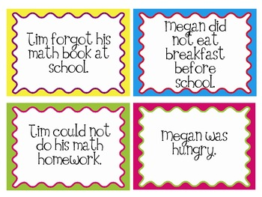

  - Use Pictures to teach Cause and Effect
I teach effect -- cause. It seems to be easier if the kids find the event & then figure out why it happened. I have some pictures from a worksheet that show different scenes of c & e. I blew them up eight years ago & I still use them. We play memery, where I have all the pictures are facing backwards taped to my board. They have to match the pictures & then decide which is the c & e. It works! I usually review once, but my kids normally have it mastered after identfying the effect & then the cause.
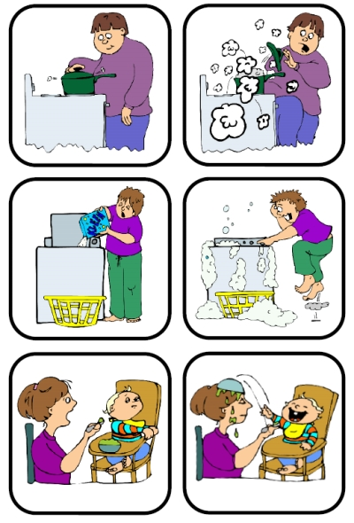

Clouds and Rain
I usually introdue cause and effect with the symbolism of a cloud as the cause, rain as the effect. We analyse a few statements and choose which is the cloud and which the rain. Then I add a puddle and show that a cause can also be an effect (as the rain is the effect of the cloud, but the cause of the puddle) I post the symbols on the wall of the classroom, and even make the first few worksheets so that they are filling in a cloud, a raindrop, and a puddle. The visual seems to help clarify for those who have trouble with this nontangible concept.
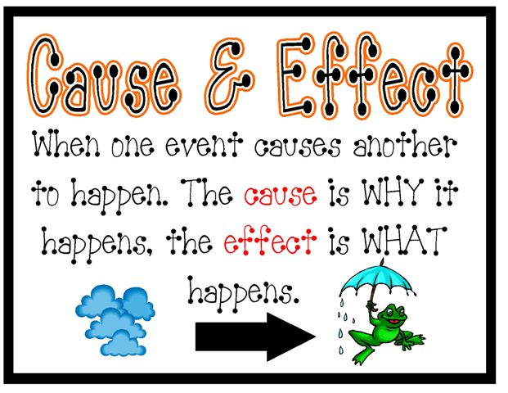

Cause and Effect Windows

After we had discussed it a lot with examples from real life, each kids made a cause & effect window. Just using construction paper - the front shows the cause and has a frame around it.. you open the 'window' and the effect is on the inside. they had to write the cause & effect at the bottom and color a picture in the main area to show it. I hope that makes sense. It's hard to describe without showing.
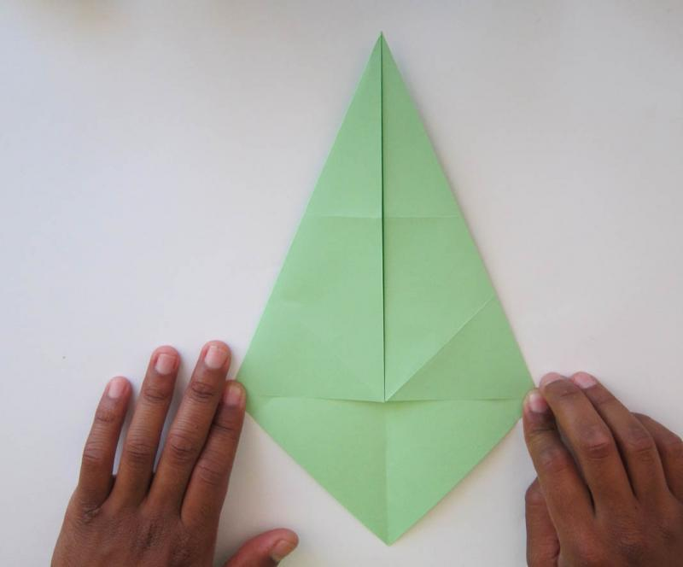
  - Puzzle Game
- have them make puzzles--one side has cause, the other the effect--cut out in puzzle shape--mix the pieces, they have to put together.
- have them make cause/effect chains--like paper chains for tree: (this is actually from a story we're reading right now) summer came/people had to leave/cat was left alone/had to survive/ate mice/made the owls mad/had to fight owls/owls were scared of cat/owls leave cat alone
- make a list of cause/effect scenarios--cut them apart --give each kid one--they have to find their "partner" and then decide which is the cause and which is the effect
- i wrote up a couple scenarios--1-2 paragraphs long (one was about how late it was so my dog was hungry he ran to his dish and whined so i fed him and he made slobbering noises. i read these aloud and ask the students to listen for causes and effects--sometimes the effect turns into the cause of something else (see chain idea above)
- have the kids create real world cause/effect passages. ie moon gets between earth and sun and causes a solar eclipse...
Cut this pictures and let the groups arrange the puzzle

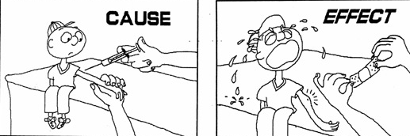

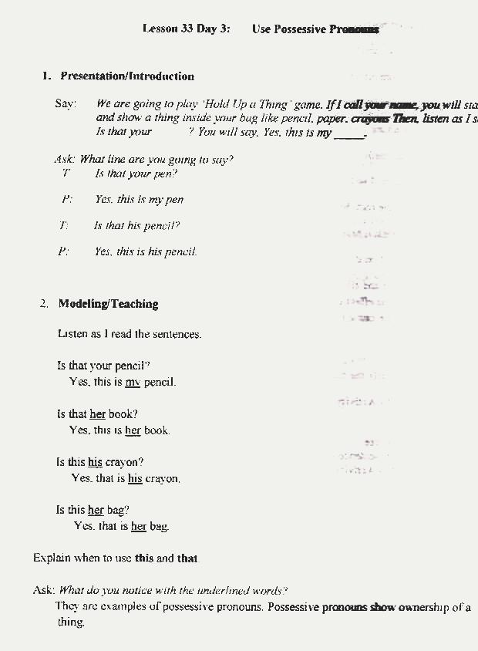
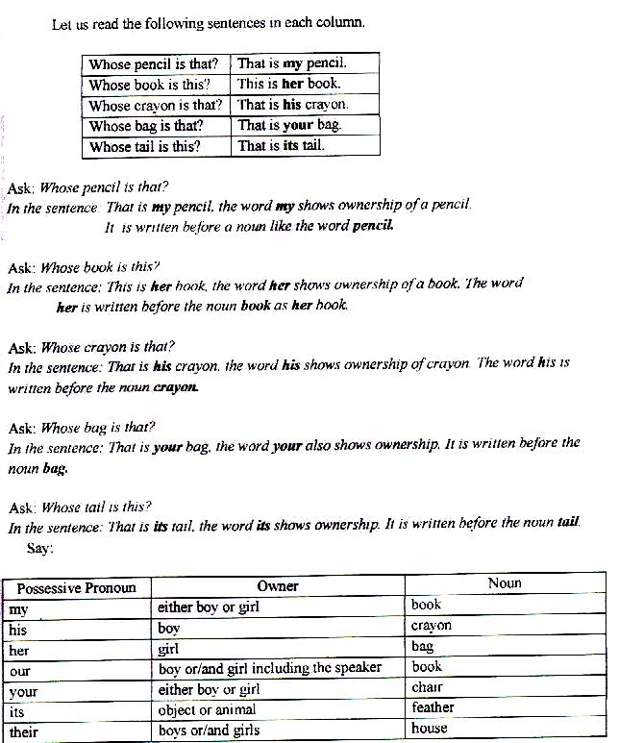

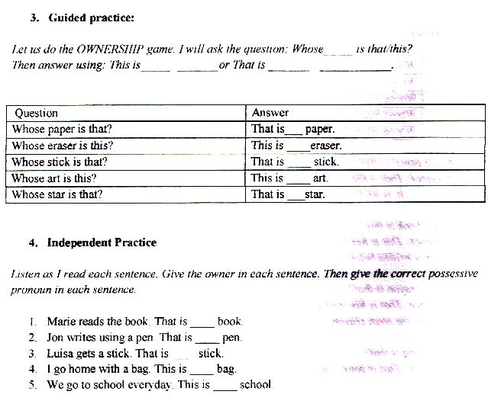
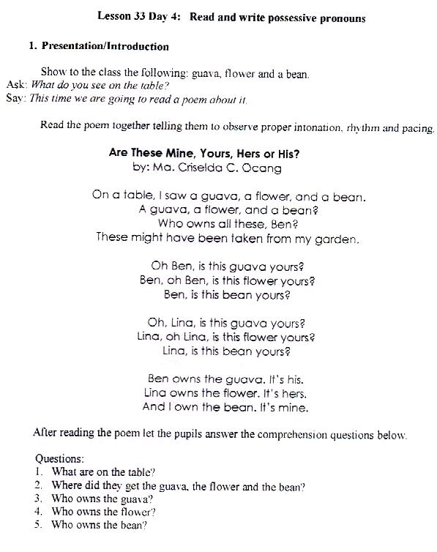
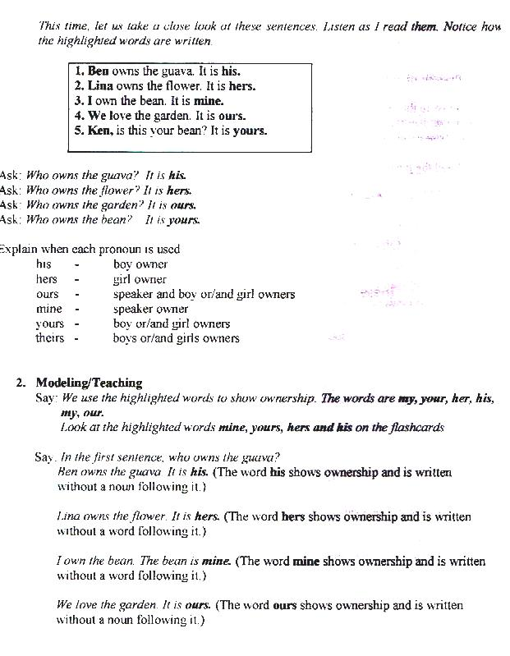

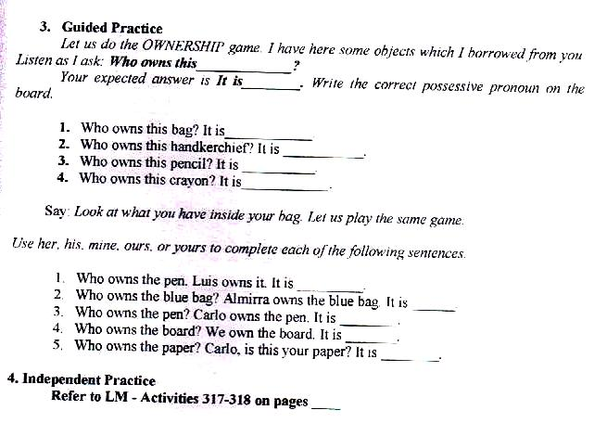

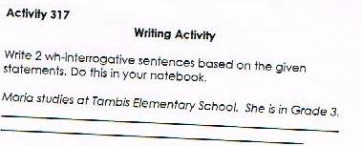

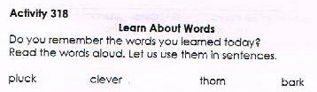

Objective: Use Possessive pronouns
Retrieved from http://busyteacher.org/14534-3-powerful-possessive-activities.html

Meaningful Objects Description
This activity allows students to get to know each other better by giving them the chance to share some personal details. It is part guessing game and part show and tell with a twist. To organize the meaningful objects description exercise, ask students to bring in one object that has significant value to them that they would like to share with the class. Also tell them to keep it hidden and to save all the details for the lesson. Begin the activity by collecting their objects in a container so the rest of the class cannot observe who puts what inside.
The first part is a guessing game in which you will pull out objects, and ask students to name them. Then hand each student one of the objects randomly. Before you begin this part of the activity you may want to review possessives and also provide the question formats you would like them to use. They will then do a mingling activity, going around the room asking each student a question about the object they have in hand. The question possibilities could be: Is this book yours or Is this your book? Yes it is my book/No it isn't my book. When students have found the owner of the object, they give the object to the owner and then continue mingling until everyone has their object back. Rules of the game you want to point out are as follows: You must wait until someone asks you a question to claim your object, and once you have found both the object you own and you have found the owner of the object you were given, you may sit down.
Once everyone is seated, the next part of the activity begins. Students will describe their object to the class in one minute. You may want to provide a challenge to each presenter. Give them a list of questions or points they should try to cover in their minute. The class pays attention to see how many of the given questions each person answers. Here are some possible questions:
- What is the object?
- Who does it belong to or who owns the object?
- Who gave it to you or where did you get it?
- How long have you had it?
- What do you use it for or What is it's purpose?
- Describe the object—size, shape, color
- Use at least six possessives in your description
- What is important or significant about your object?
To wrap up the activity, and ensure good listening, allow the students to debrief about the objects and have a short discussion.

Who Lives in My House?
This activity incorporates a lot of vocabulary practice, and is also a memory game. It has three parts. The first part requires students to write down three to five sentences describing their homes.
An example could be: My family lives in a house/apartment/condo. My (Our) house has three bedrooms. My house has one bathroom and a large kitchen.
The second part is a family description of their home in one to two sentences.
For example: My mom and dad have the big bedroom, I have my own room and my brother shares a room with my baby sister.
Lastly, students go in rounds and read one of their sentences to the group. The next person describes what the first person said, and then they add a sentence to the round. Each student then does the same thing trying to remember one detail of every student in order. This can go around until the sentences are exhausted, and the students need help remembering. It looks like this.
Student 1 (Molly): My house has two bedrooms.
Student 2 (Jamie): Molly's house has two bedrooms, but mine doesn't. My house has four bedrooms.
Student 3 (Greg): Molly's house has two bedrooms, Jamie's house has four bedrooms and my house has two bedrooms too.
This activity takes some set-up, but if you have played any memory games before the instructions should fall into place. As always, provide good examples and remind students how to practice possessives.

Goofy Cards
Make a set of cards of nouns and verbs. Divide the class into two teams. Each team should have a stack of cards. Taking team turns, one student at a time draws two cards. To get a point, they must generate a grammatically correct sentence using either possessive pronouns or student names. Example cards could be:
Spider | Travel
Carrot | Exam
Drink | Flower
Travel | Dance
Exam | England
A student on team one draws two cards—Travel and Carrot. The student must make a correct sentence using any tense and with possessives.
Answer: The carrot's dream was to travel the world. The team gets a point. If you want the activity to be even more nonsensical, you could require each team to devise a story sentence by sentence. Each time they draw cards the student would continue adding detail to the story.
Objective: Read and Write Possessive

Song Worksheet

A song by Crashed The Wedding . I used this songworksheet to review possessive pronouns (and to have fun). Students should listen and circle the correct pronouns. At the end I let them relax and watch the video by walkofftheearth. They made a fantastic remix on the song.

Cra VERSE-1
...............'m so rushed off ............... feet, (oh-oh)
Looking for Gordon Street,
So much ............... need to say,
...............'m sorry that ...............'s on ............... wedding day...
' Coz ...............'s so right for ..............., (oh-oh)
............... daddy disagrees,
...............'s always hated ...............,
'Coz ............... never got, a j-o-b...
CHORUS-1
'Coz ...............'s mine,
And ...............'m glad............... crashed the wedding.
...............'s better than regretting.
............... could have been a loser kid
And ran away and hid,
But ...............'s the best thing ............... ever did.
'Coz ...............'s true love that lasts forever
And now ...............'re back together,
As if ............... never met ...............
So looking back,
...............'m glad ............... crashed the wedding...
VERSE-2
The neighbours spread the word (damn),
............... mom cried when ............... heard,
............... stole ............... girl away,
From ............... gathered there ............... day.
CHORUS-2
And, just in time,
And ...............'m glad ............... crashed the wedding.
...............'s better than regretting,
............... could have been a loser kid
And ran away and hid
............... said ...............'d do ............... and ............... did.
'Coz its true love that lasts forever
And now ...............'re back together
As if ............... never met ...............
So looking back,
...............'m glad ............... crashed the wedding...
VERSE-3
So please stop being
Mad at ............... for taking ............... away, 'coz
Anyway ............... didn't want to stay.
So please believe ............... when............... say
CHORUS-3
...............'s glad............... crashed the wedding
...............'s better than regretting...
The ring ............... got was lame.
............... couldn't take the pain;
............... didn't want a silly second name,
'Coz true love lasts forever
And now ...............'re back together.
............... might as well forget ...............
And walk away[Repeat Chorus-3]
W THE MISSING WORDS
- SUBJECT PRONOUNS: I, he, she, it, we, you
- OBJECT PRONOUNS: me, her, everybody
- POSSESSIVE PRONOUN: mine
- POSSESSIVE ADJECTIVES: my, her
- DEMONSTRATIVE ADJECTIVES: that

Answer key

VERSE-1
I'm so rushed off my feet, (oh-oh)
Looking for Gordon Street,
So much I need to say,
I'm sorry that it's on her wedding day...
'Coz she's so right for me, (oh-oh)
Her daddy disagrees,
He's always hated me,
'Coz I never got, a j-o-b...
CHORUS-1
'Coz she's mine,
And I'm glad I crashed the wedding.
It's better than regretting.
I could have been a loser kid
And ran away and hid,
But it's the best thing I ever did.
'Coz it's true love that lasts forever
And now we're back together,
As if he never met her
So looking back,
I'm glad I crashed the wedding...
VERSE-2
The neighbours spread the word (damn),
My mom cried when she heard,
I stole my girl away,
From everybody gathered there that day.
CHORUS-2
And, just in time,
And I'm glad I crashed the wedding.
It's better than regretting,
I could have been a loser kid
And ran away and hid
I said I'd do it and I did.
'Coz its true love that lasts forever
And now we're back together
As if he never met her
So looking back,
I'm glad I crashed the wedding...
VERSE-3
So please stop being
Mad at me for taking her away, 'coz
Anyway she didn't want to stay.
So please believe me when I say
CHORUS-3
She's glad I crashed the wedding
It's better than regretting...
The ring she got was lame.
She couldn't take the pain;
She didn't want a silly second name,
'Coz true love lasts forever
And now we're back together.
You might as well forget her
And walk away
[Repeat Chorus-3]

Grammar Exercises

Online Programs and Online Quizes are all free and give assessment and interpretationon the scores of the learners.

Follow this link for the online quiz.

myenglishpages.com/site_php_files/grammar-exercise-possessive-adjectives.php#.VNP0dixv-LI

3. Pronoun Substitution

Retrieved from: www.superduperinc.com

Materials:
Various objects (balls, blocks, books, games), pictures of proper nouns (famous people, places, and things), sentence strips, writing
instruments (pens, pencils, markers, crayons), and chart paper or notebook paper.
Directions:
1. Place objects and pictures around the room where students can easily see them.
2. Number each object/picture and have a sentence strip for each object/picture that either describes or begins a story about the object/picture. For example, with soccer ball you might write on the sentence strip, “Michael likes to kick the soccer ball.”
3. Have students rewrite the sentence using the appropriate pronouns. For example, “He likes to kick it.”
4. After all students have a chance to write severalsentences/paragraphs using appropriate pronouns, allow some time for them to share and identify aloud the pronouns they have on their papers.

Extension Activities:
• For older students, or after students are beginning to master
pronouns, have students use the sentences as a writing prompt and continue writing a paragraph or essay using appropriate nouns and pronouns.
• Put items in bins around the room and set up “stations” so that students are able to move around the room
and write.
• If you have access to a SMART
Board or Promethean Board, simply display the
objects/pictures and sentences on the board.

Pronoun Identification
Materials:
A piece of writing to read aloud that uses many pronouns.
- For a fun way to review pronouns,read a loud to the
whole class from a book or magazine.
2. Instruct students to clap their hands everytime they hear you say a pronoun.

Extension
Activity:

For older or more advanced students,choose a different action for each type of pronoun.
For example,clap for personal pronouns,snap for possessive pronouns, stomp for relative pronouns,and wave for reflexive pronouns.
Example reads:

The Lion and the Mouse

http://read.gov/aesop/007.html
A Lion lay asleep in the forest, his great head resting on his paws. A timid little Mouse came upon him unexpectedly, and in her fright and haste to get away, ran across the Lion's nose. Roused from his nap, the Lion laid his huge paw angrily on the tiny creature to kill her.
"Spare me!" begged the poor Mouse. "Please let me go and some day I will surely repay you."
The Lion was much amused to think that a Mouse could ever help him. But he was generous and finally let the Mouse go.
Some days later, while stalking his prey in the forest, the Lion was caught in the toils of a hunter's net. Unable to free himself, he filled the forest with his angry roaring. The Mouse knew the voice and quickly found the Lion struggling in the net. Running to one of the great ropes that bound him, she gnawed it until it parted, and soon the Lion was free.
"You laughed when I said I would repay you," said the Mouse. "Now you see that even a Mouse can help a Lion."
A kindness is never wasted

Movie Segments to Assess Grammar Goals

Movie Segments to Assess Grammar Goals contains a series of movie segments and activities to assess or practice grammar points through fun, challenging exercises. Here you will find the movie segments, the lesson plans, printable worksheets with answer key for each activity, and the tips to develop your own grammar activities with the DVDs you have at home. New activities are posted regularly. Teaching grammar with movie segments is inspiring and highly motivating.

Ice Age: Possessive Pronouns
Ice Age is one of my favorite animated movies. This scene is great and I used it to practice the use of adjective pronouns, not for beginners, but basic learners. I hope you enjoy it!

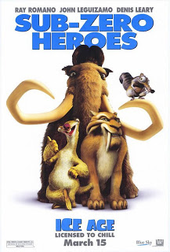

Watch the movie segment about an eskimo family that is attacked by a group of sabre-tooth tigers. Then complete the blanks with adjective pronouns.

Answer the correct word found in their movie dialogues.

The eskimo tribe lived in the woods. The sabre-tooth tigers invaded __________ territory.
2. The eskimos had some dogs. They barked to warn _________ owners about the dangerous tigers.
3. Kinu, the eskimo, used ___________ spear to fight the tiger and protect ________ family.
4. Jana, the eskimo mother, held __________ baby before Diego, the tiger, attacked it. She would never leave _______ child behind.
5. The tiger grabbed ____________ necklace, but it didn't grab ___________ baby.
6. ________________ husband could not help her because of the tigers. Kinu wanted to help _______________ wife and child, but she ran away with _________ baby.
7. The dogs defended ______________ owner from the tigers.
8. The tigers were unhappy with Diego because of __________ incompetence to get the baby.
9. Kinu found _________ wife's necklace. _______________ friends followed him to look for _________ wife and child.
10. Did you like the segment? What's __________ opinion about it?
11. I (liked/didn't like) it. In ___________ opinion, the segment is (great / terrible / fantastic / etc).
AnswerKey:
1.their
2.their
3.his/his
4.her/her
5.her/her
6.her/his/their
7.their
8.his(its)
9.his
10.your
11. My

