Unit 4: Week 3 (Lesson 30)
 | Day 1 |  | Day 2 | Day 3 | Day 4 | Day 5
Overview/  Objectives | ● Use a story map  in sharing a  story.  ● Read a poem with  proper rhythm  and intonation.  ● Interpret simple  maps of places. |  | ● Interpret simple  maps of places.  ● Follow directions.  ● Read words  and phrases with  –wr- beginning letters. | ● Ask Wh-  questions.  ● Answer Wh-  questions.  ● Read words,  phrases and a  poem with – wr-  beginning words. | ● Write a simple story.  ● Read words, phrases  and a poem with kn-  beginning words. | ● Write simple story.
Materials | ● Paper Bag  ● Picture of Pappy  ● Picture-stories/  Comic strips  ● LM Activity 289 |  | ● Simple Location  map  ● LM Activities 290- 291 | ● Manila Paper for  group activities  ● LM Activities  292-293 | ● Picture of a bird  and a boy scout  ● Story Grammar  ● Lm Activities  294- 296 | ● Manila Paper for group activities
TEXT  USED | Pappy the Paper Bag from http://www.shortstories.net/ |  |  |  | Tina, the Lost Bird
Procedure
(5 min)
● Show a simple map of where Pappy lives. Key words are introduced through a finger-walk activity.
● Show a paper bag and a picture to build on prior knowledge.
(10 min)
● Show a simple map of different supermarkets in the city and ask them WH-questions to locate places in the map.
●Post the map on the board to draw attention.
(5 min)

● Read the first paragraph of the story with the pupils.

● Ask WH-questions
On the read paragraph to jumpstart lesson.

0
(5 min)
● Show the pictures.
● Allow pupils to tell what they see.

(10 min)
●Review the
elements of a
story.
●Discuss how t do
story grammar.
(10 min)
● Ask the pupils to answer the WH- questions (What is your name? Who is your mother? When is your birthday? Where do you leave? Why do you go to school?

(5 min)
Reiterate the elements
elements of a story
(10 min)
●.Ask pupils to read
they the story.
● Let them work on
story grammar.

(15 min)
● Allow each group
to re-tell the story
using the story
grammar.

(10 min)
Phonics:
● Flashcard drill on
Words learned
From Day 2 and 3.
● Present and model
Reading groups of
words with kn-
● Let pupils read the
Words and groups
Words LM Activity
295
(20 min)
● Allow pupils to
Write a story
by writing their
answer on
guide questions
leading to the
writing of a
story.

(15 min)
● Allow pupils to
share their
story to class.

(25 min)
Read and enjoy the
story with the pupils.
Use comic strips you read the story.

(20 min)
● Allow pupils to
draw a picture
story and share
and the output to
class.
( 5 min)
● Review how to
interpret location
maps.

(10 min)
● Interpret with the
pupils the simple
map through finger-
walking by following
direction.

(10 min)
● Allow pupils to
make a simple
location map of
their school.
● Let them present
their work to class.

(15 min)
Phonics:
● Flashcard drill on
words learned from
the pastweek/lesson
● Present word with
wr- as in wrong for
model Reading the
wounds.

(10 min)
● Discuss Who-questions.

(10 min)
●Read with the pupils the second to the fourth paragraph of the story again and practice the used of WH questions (Chunking Method where WH-questions will be devised from the read paragraph

(15 min)
● Allow pupils to read assigned paragraph/s of the story ask and ask to them to formula as many Wh-questions from what they have read LM Activity 292
the output.

● Let pupils read the
words and groups
of words and let
them answer C LM
Activity 291
(10 min)

Phonics
(10 min)
● Flashcard drill on
Words learned from
Day 2.
● Model reading groups
Of words with wr-
● Let pupils read the
Words and group of
Words.
● Allow pupils to read
Read the poem with
wr- words and answer
comprehension
questions. LM Activity
293

Unit 4: Week 3 (Lesson 30)
Pappy, the Paper Bag
A. Pre- Reading

1. Unlocking/ Vocabulary & Concept Development
( mission, abandoned, damage, contaminating, enthusiastic, avoid)

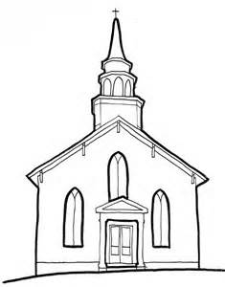
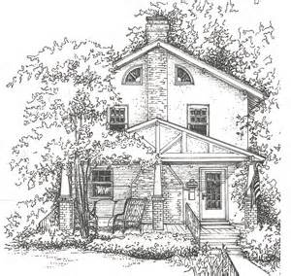
Ipil St.
N
Banaba St
W E
S
Church
Neighbor’s House
Pappy’s House

-- -- -- -- -- - - -- -- -- --- -- -- -- -- -- -Narra St.- -- -- -- -- - -- -- -- -- ---
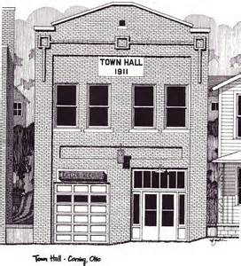

Mayor’s Office

Show and post on the board the simple map of where Pappy lives. Tell them that they need to listen to you so that they will be able to help Pappy find his way to the different places on the map.
Do the game/ activity below with the pupils.

Say: Here is how to finger-walk. First, put your index and pointer finger on Pappy’s house and walk to the streets on the map using your fingers. Everybody, show me how to finer-walk in the air, how about on your seatmate’s back and on your desk/ armchairs. Well done! We are now ready.
Let us start with the finger-walking game.

(Do the first one. Pappy- the Paper bag has a mission. He has an assignment – a task that he needs to do. He started walking and went to the mayor’s office to tell him of his mission. Show how to finger walk up to the crossing)

Hey kids, pappy needs someone to continue walking with him because his friend Totie abandoned him on this mission- he was left alone on this. (Teacher calls on one student).
Pappy and (name of pupil called) will walk across Narra St. and along the way they will see a river filled with garbage and plastic bags. Oh, those plastics bags are floating on the river. They harm, they destroy our river. The plastic bags caused damage to our river- they are contaminating our water. They are making our river dirty. Then Pappy and the pupil will stop at the Mayor’s office.
Let us give Pappy time to talk to the Mayor.
This time let me call on another pupil to continue on the mission with Papp. (Call another pupil to act as Pappy too.) Pappy and the pupil continue walking to their neighbours. Walk straight, and then turn left. You are now at friend’s house. They were enthusiastic- they felt excited and happy.
(Call on the other pupils to finger walk.
Go to church. Walk straight to the corner and turn right. Avoid the hole on the way.
Stay away from the hole. You are now in front of the church.
2. Motivation Question:
What do you usually use for the things you buy in the market?

3. Motive Question:
Find out what we can use for the things we buy in the market.

(Note: Make sure that you have the picture of enlarged Pappy and a paper bag in a mystery box before starting the class)

Show a Mystery Box containing the paper bag and the picture of the Pappy. Tell them that there are two things inside the mystery box and that you need to find out what are these things. Pull out the first thing (paper bag) slowly from the mystery box and let them tell what it is.
When the paper bag is already shown, ask them: Do you know what this is?
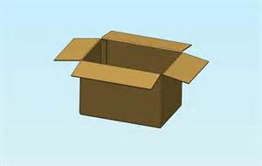
Pull out the second thing (picture of Pappy) and let the pupils guess its name. Allow the pupils to speak and tell their own descriptions about the picture and say: This is our friend, Pappy-the paper bag. Ask them where they usually use paper bags and if those bags are used in their localities.
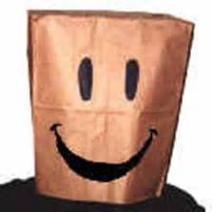

(This activity will be used as to introduce the key words and at the same time to practice on finger-walking for the interpretation of location maps for the next day.)

Learn About Words

A. Let us enjoy looking far and understanding the key words by doing the finger –
walking activity. We will use an enlarged map for this activity. Try look at its copy
below.

You need to listen carefully to the directions that the teacher will give you. Enjoy finger-walking on the map as you also find the meaning of the following words.

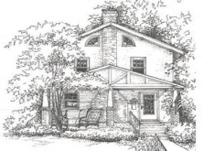
N
Ipil St.
Banaba St
W E
S
Neighbor’s House
Church
Pappy’s House
Narra St.
---- -- -- - - -- I -- -- --- -- -- -- -- -- .----- -- -- -- - -- -- -- -- - -- -- -- -- --- -- --- ---- --

Mayor’s Office

Damage
abandoned
mission

avoid
contaminating
enthusiastic

B. Read this with your teacher and enjoy it along with the enlarged comic strips.

PAPPY THE PAPER BAG

Plastic bags are used all over the world to carry everyday items such as bread,
clothes, toys, and lots of other things. But Pappy, the hero of our story , wasn’t a
plastic bag like all the rest- he was a very special paper. And Pappy had a mission to
complete……..
Pappy knew that all over the world there were million of plastic bags that had
been abandoned by people. These ended up floating I the seas and oceans and
contaminating the water. These caused damage to the creatures that lived nearby.
Pappy didn’t want things to go on this way. So he came up with a plan to put an end
to plastics bag being thrown away. One day he went to visit a big supermarket to talk
to the manager.
“Hello Mr. Manager, my name is Pappy and as you can see I’m a paper bag. I
want to suggest an idea to avoid using plastic bags in shopping,’’ Pappy declared.
“What? Have you gone mad? Where else would people put their things?”
answered the manager, shocked.
“Very simple,” smiled Pappy. “My plan is to replace plastic bags with paper ones
like me because we don’t pollute the environment. I’d also like to suggest something
else: that we reuse both plastic and paper bags instead of throwing them away ,”
Pappy went on, sounding very enthusiastic.
“That’s not a bad idea. But why is it better to use paper bags and reuse them?”
asked the manager, interested in what he was hearing.
“Well, because first it would mean fewer plastic bags spoiling the environment.
But it would also save us money. We would be reusing all our bags without needing
to buy a new ones,” Pappy explained.
The manager of the big supermarket realized that they were wasting resources,
and that this could be avoided. So the following week, only paper bags were given
out to the shoppers.
Pappy went all over the world – one supermarket at a time. He spread his
message that we should always re-use our bags, encourage recycling and look after
the planet.

B. During Reading
Read with the pupils the story “Pappy, the Paper Bag” along with the enlarged comic strips for reiteration. Make sure that the enlarged comic strips are ready before starting to read the story. Let them enjoy the story by reading one paragraph at a time.)

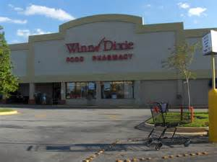
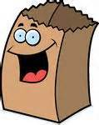
Hi, I’m Pappy

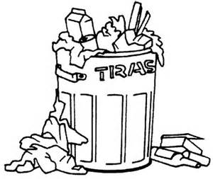
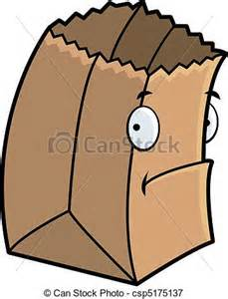

Try me
I’m a better choice
?
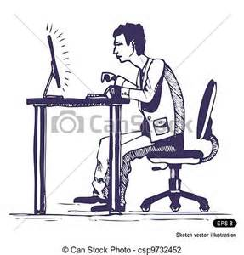
Manager

You save the environment and money with me
Better

Manager

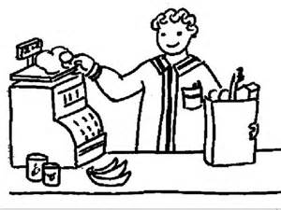
Hello world…use me

C. Post Reading
Divide the class into five (5). Allow each group to draw a picture showing the story
1events. Each group will be given 2 paragraphs to work on. Pupils will share their
output to the class.

C. In each group of five, you will make a picture of story. You are going to draw
on a coupon bond the flow of the story we read. Each of you will be give two
paragraphs to work on. Be ready to share your output.

Lesson 3 Day 2

Skill Lesson 1: Interpreting Location Maps

A. (Note: before starting Day 2 be sure to prepare a larger replica of the map
below for another finger-walking activity that will focus on Wh-question and
following directions.)

Finger-Walking Activity

You are going to finger-walk again and this time by following some directions.
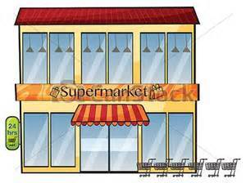
N
house
Pappy's
Mango St.
Green Supermarket
E
W
Banana St.
S
Totie's House
Cast Saver's Supermarket
Mango St.
Banana St.

Good Supermarket
Better Supermarket

Directions for Finger-Walking Activity:

1. Pretend to be Pappy. Walk to your gate, to Banana Street, and turn right. You are
now facing south. Walk straight until you reach the corner.

To what direction did Pappy walk?
Pappy was facing ______________!

2. Wait for your friend Totie (one of your classmates should act as Totie who will finger-
walk with Pappy) and turn right. You are now facing west. Walk straight to Green
Supermarket.

To what direction did Pappy and Totie walk?
Pappy and Totie were facing ____________!

3. From Green Supermarket (Wait for your other classmates to finger-walk and pretend
to be Pappy and Totie.) Face South and walk across Mango Street to Good
Supermarket . Allow twenty seconds for Pappy to talk to the manager of Good
Supermarket. While he is talking to the manager, Totie should wait outside facing
East.

To what direction does Totie face?
________ is facing ___________!

4. From Good Supermarket, Pappy and Totie walk facing east and walk facing
East and walk straight to Better Supermarket. Allow twenty seconds for Pappy to
talk to the manager of Better Supermarket. While he is talking to the manager Totie
should wait outside facing north.

To what direction does Totie face?
_______ is facing ___________!

5. From Better Supermarket, you are now facing north, walk across the Mango Street to
Cost Saver’s Supermarket. Allow twenty seconds for Pappy to talk to the manager of
Cost Saver’s Supermarket. While he is talking to the manager Totie
should wait outside facing South.

To what direction does Totie face? _____________ !

6. From Cost Saver’s Supermarket, Pappy and Totie face south. They would turn right,
walk to the corner and Pappy will say “I’m happy that I was able to tell all the
managers to use paper bags in their supermarkets. I’ll go home now” Totie will say,
“Goodbye Pappy. I enjoyed the walk.

7. Where will Pappy go now? What direction will he be facing? Why will he walk facing
that direction? How about Totie? Where will he walk? What direction will he be facing
as he walks home? Why will he walk facing that direction.

Post the map on the board draw attention. Ask Wh-questions about the map. (e.g. What are the different places on the map? Who would like to finger-walk on the streets o the map? Where is Pappy’s house? Why is Pappy happy?)

Review how to interpret location maps. Let them show you where North, East, West and South directions. Model it first. Then, allow the entire class to do it, then, by groups. Finally, individually. Have fun.
Do this finger-walking exercise first with the pupils.
Everybody, show me how to finger-walk in the air, how about on your seatmate’s
back, on your side, and on your armchair.

By following directions below allow pupils to interpret the map posted on the board.

Directions for Finger-Walking Activity:

1. Pretend to be Pappy. Walk to your gate, to Banana Street, and turn right. You are
now facing south. Walk straight until you reach the corner. (Teacher asks: To what
direction did Pappy walk? Tell pupils to say: Pappy was facing south.)

2. Wait for your friend Totie (one of your classmates should act as Totie who will finger-
walk with Pappy) and turn right. You are now facing west. Walk straight to Green
Supermarket. Teacher asks: To what direction did Pappy and Totie walk? (Tell
Pupils to say: Pappy and Totie were facing west). Allow 20 seconds for Pappy to
talk to the manager of Green Supermarket.

3. From Green Supermarket (Wait for your other classmates to finger-walk and pretend
to be Pappy and Totie.) Face South and walk across Mango Street to Good
Supermarket. Allow twenty seconds for Pappy to talk to the manager of Good
Supermarket. While he is talking to the manager, Totie should wait outside facing
East. (Teacher asks: To what direction does Totie face? Tell pupils to fill the blank:
________ is facing ___________.) After filling the blank ask them to say it.

4. From Good Supermarket, Pappy and Totie walk facing east and walk facing
East and walk straight to Better Supermarket. Allow twenty seconds for Pappy to
talk to the manager of Better Supermarket. While he is talking to the manager Totie
should wait outside facing north. (Teacher asks: To what direction does Totie
face? Tell pupils to fill the blank: _______ is facing ___________.) After filling the
blank ask them to say it.

5. From Better Supermarket, you are now facing north, walk across the Mango Street to
Cost Saver’s Supermarket. Allow twenty seconds for Pappy to talk to the manager of
Cost Saver’s Supermarket. While he is talking to the manager Totie should wait
outside facing South. (Teacher asks: To what direction does Totie face?

6. From Cost Saver’s Supermarket, Pappy and Totie face south. They would turn right,
walk to the corner and Pappy will say “I’m happy that I was able to tell all the
managers to use paper bags in their supermarkets. I’ll go home now” Totie will
say, “Goodbye Pappy. I enjoyed the walk”.

7. This time ask pupils the following questions: Where will Pappy go now? What
direction will he be facing? Why will he walk facing that direction? How about Totie?
Where will he walk? What direction will he be facing as he walks home? Why will he
walk facing that direction.

B. Allow each group to make a location map of the school and tell them to present the
output by identifying where the following places are located: office of the principal,
the classroom, school gate, comfort rooms and canteen.

Skill Lesson 2: Reading words and phrases with wr-
A. Read the following words. Take note of the pictures for these words.
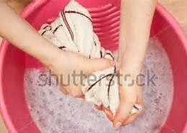
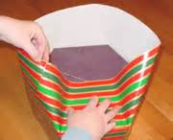
wrap wring

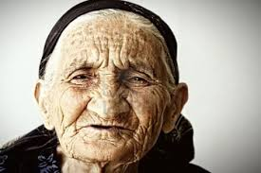
wreath

wrinkle
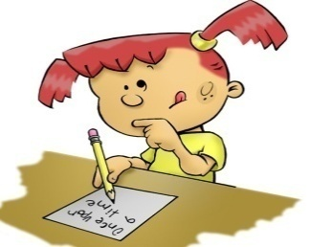
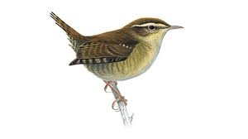
wren write

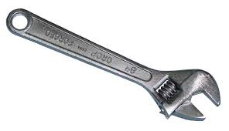
wrench

Complete each sentence using the words above.
1. Grandmother has _______________s on her face.
2. I can see a _____________ during Christmas.
3. My sister will __________ a gift for Mother.
4. I need to ________ the towel to remove the water from it.
5. Karen will __________ a letter to her friend.
6. I want to have a ____________ as my pet.
7. Father used a ___________ to turn the bolt.

B. Read the following.
wrap and taps
wreath for Christmas
a flying wren
needs a wrench

wring the towel
wrinkle in an old woman’s face
to write a letter
C. Allow pupils to match the word or group of words from Column A to Column B to form a sentence that makes sense. Then let them read the sentences. Allow the pupils to re-read the words and phrases by group and by pairs. Tell them that for wr- won’t the first letter is silent. Then ask pupils to look at the list of words and read them. Read the group of words too with wr-
Match the words or phrases I Column A to the words and phrases in Column B to form sentences that make sense.
Column A Column B
1. Brenda a. wrong to love our neighbour
2. Grandmother b. wraps a box of chocolate for grandmother
3. The school receives c. a wreath for valentine
4. The pupils d. wrings the towel for Ben
5. It is never e. write a letter to a Teacher

Lesson 3 day 3: Wh-Questions
A. Recalling the Story
Recall the story “Pappy the Paper Bag”. Read with the pupils the first paragraph. Ask: What do people use to carry everyday items such as bread,
Clothes and other things? Who was the hero of the story? Why is Pappy a special paper bag?

Post or write the following questions on the board. Ask them to focus on the first word in each question?

What are being used to carry those things e buy from supermarket?
Where did Pappy go to tell the good news about paper bag?
When is it necessary to use paper bags?
Who is the hero in our story?
Why is Pappy a special paper bag?

B. Discuss Wh- questions by telling them how these questions are formed

Question words are also called wh-questions because they include the letters ‘W’ and ‘H’.
Wh-Question | Answer/ Response | Example
Who | Person | Who’s that? That’s Nancy.
What | Object, idea or action | What do you do? I am an engineer.
When | Time | When do you go to work? At 7: 00 in the morning
Where | Place | Where do you live? In Binmaley, Pangasinan
Why | reason | Why do you keep early? Because I need to get up early
You can use the table to give an elaboration. Be sure to have a copy of these materials on a Manila paper.
Wh- Questions | Sample Questions and Answers
Who | Who is that boy? | 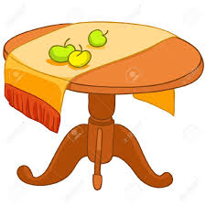
What | What is on the table?
When | When is the party? | 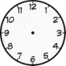
Where | Where is your book? | 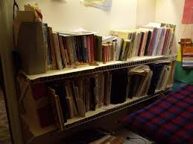
Why | Why are you late? | 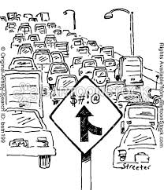
C. Practice Exercise on Wh- Questions:
You will be grouped into 3. Read the assigned paragraphs of the story and write as many Wh- questions as you can ask from what you have read. Be ready to share
The outputs.
Group 1 – fifth to sixth paragraphs
Group 2 – seventh to eight paragraphs
Group 3 – ninth to tenth paragraphs
Where __________________________________________ ?
WHY ____________________________________________?
When ___________________________________________ ?
What ____________________________________________ ?
Read with the pupils the second to the fourth paragraph of the story again and
Practice the use of Wh-questions (The Chunking Method will be used where Wh-
questions will be devised from the read paragraph). On this activity anyone could
raise a question about what was read. Make sure that you write the questions on
the board for scrutiny and explanation to elaborate on the formulation of Wh-
questions.

Lesson 3 Day 4: Writing a Simple Story

A. Show the picture of a bird and a boy scout to the pupils. What do you see? What
is this? (Point to the bird) How about this one? Who is this? (Point to the Boy
Scout) Tell them that you are going to have a story later.

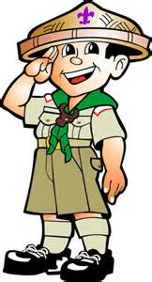
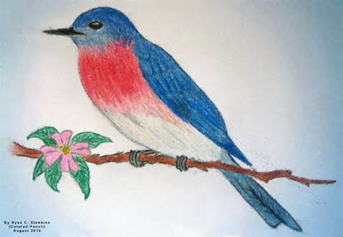

B. Review the elements of a story and discuss how to do a story grammar in an
organized manner

A short story tells about a series of events.

Any story, like Belling the Cat, has characters. Story characters may be a person
or an animal. In Belling the Cat, Pat the Cat and the Three Mice were the
characters.

The setting of a short story refers to the time and place in which the story
happened. The setting of Belling the Cat is in the house and one morning.
Plot refers to the sequence of events in the story. Can you tell the events in
Belling the Cat?
After reviewing the elements of a story, present how a story grammar is done by
showing and explaining to them the simple story grammar that follows.

A simple story grammar (Hermosa, 1995)
Categories | Example of a well-formed story
Setting: When and where did the story happened?  Characters: Who are the characters in the story? | Once, there was a rooster named Tilaok. He lived in a barn on a farm near the edges of the woods  Tilaok, the Rooster
Plot:  Initiating Event | One, day, the fox came who told Tilaok what beautiful voice he had. He asked Tilaok to come down and sing for him
Initial Response | Tilaok who was proud of his voice wanted to please the fox.
Attempt | He flew from the top of a barn to the ground and began to sing.
Consequence (Outcome/ Result) | Suddenly, the fox bit Tilaok’s neck and run off with him into the woods.
Reaction | Tolaok was very sad. He wished he had not been so foolish.

Discuss thoroughly the parts of a plot.

Initiating event::
An action or event that shows the problem of the main character.

Internal response:
The character’s main reaction to the initiating event, in which the character sets
a goal or attempts to solve a problem.
Attempt:
The character’s effort to achieve the goal or to solve a problem
Several attempts, some failed, may be evident in an episode

Consequence:
An action or illustration that results from the characters success or failure to
Reach the goal or to lose

Reaction:
An idea, emotion of further event that expresses the character’s feeling about
success or failure in reaching the goal or solving the problem the story to some
broader set of concerns

Process the given sample story grammar:

Ask: What is the setting of the story? Who is the main character? What happened one
day? What did Tilaok do? What did the fox do? What did Tilaok feel?

